

Software Requirements Specification

**Version1.1**

**Quốc Nhân**

**15/11/2019**

**VERSION HISTORY**

|  |  |  |  |  |  |
| --- | --- | --- | --- | --- | --- |
| **Version #** | **Implemented**  **By** | **Revision**  **Date** | **Approved**  **By** | **Approval**  **Date** | **Reason** |
| 1.0 | Anh Minh | 12/11/2019 |  |  | Create Document SRS version 1.0 |
| 1.1 | Nhan Pham | 15/11/2019 |  |  | Update v1.1 |
| 1.2 | Nhan Pham | 20/06/2020 |  |  | Review by Quang |
|  |  |  |  |  |  |

Table of content

**I. USE CASE DIAGRAM 2**

**1. Use Case Diagram General 2**

**2. Use Case Diagram Leader 3**

**3. Use Case Diagram Department Head 4**

**4. Use Case Diagram Admin 4**

**5. Use Case Diagram Employees 4**

**II. ENTITY TITLE 4**

**III. USE CASE LIST 4**

**IV. USE CASE DESCRIPTION 5**

**1. Login 5**

**2. Logout 6**

**3. Search personnel list 7**

**4. View personnel list 7**

**5. Upload organizational chart 8**

**6. View organizational chart 9**

**7. Add company policy 10**

**8. Edit company policy 10**

**9. Delete company policy 11**

**10. View company policy 12**

**11. View account information 16**

**12. Add account 12**

**13. Hide account 13**

**14. Edit account 13**

**15. Classify 14**

**16. View real estate listings 19**

**17. Search real estate listings 19**

**18. View detail project 19**

**19. Add real estate listings 19**

**20. Edit real estate listings 19**

**21. View business results 19**

**22. Upload business results 19**

**23. Filter business results 19**

**24. View table comparing business results 19**

**25. View graph of business results 19**

**26. Sign up for business trip 19**

**27. Browse business trip 19**

**28. Cancel business trip 19**

**29. Locate business trip 19**

**30. View business trip history 19**

**31. Search business trip history 19**

**32. Register to quit your job 20**

**33. History of leave 21**

**34. Approval of leave 20**

**35. Search of leave 19**

**36. Happy Birthday 22**

1. **USE CASE DIAGRAM**
2. **Use Case Diagram General**

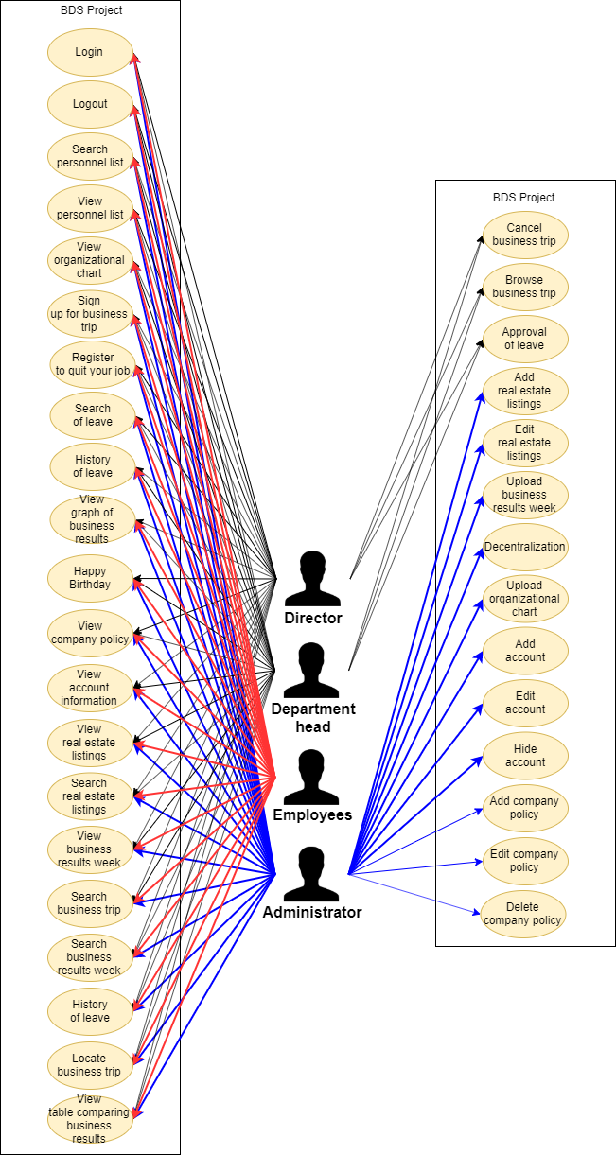

1. **Use Case Diagram Director**

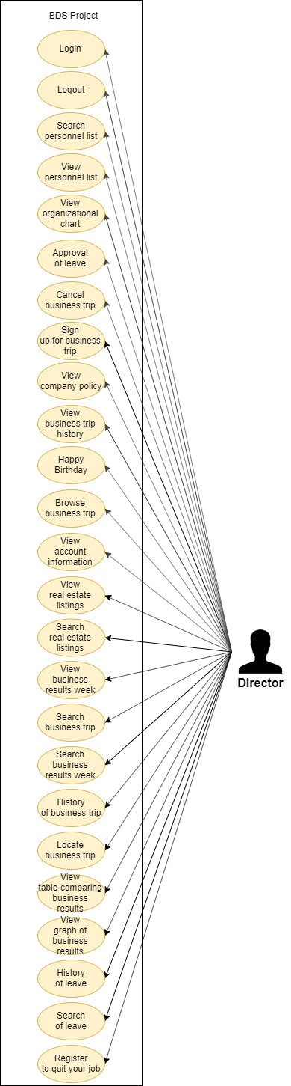

1. **Use Case Diagram Department Head**

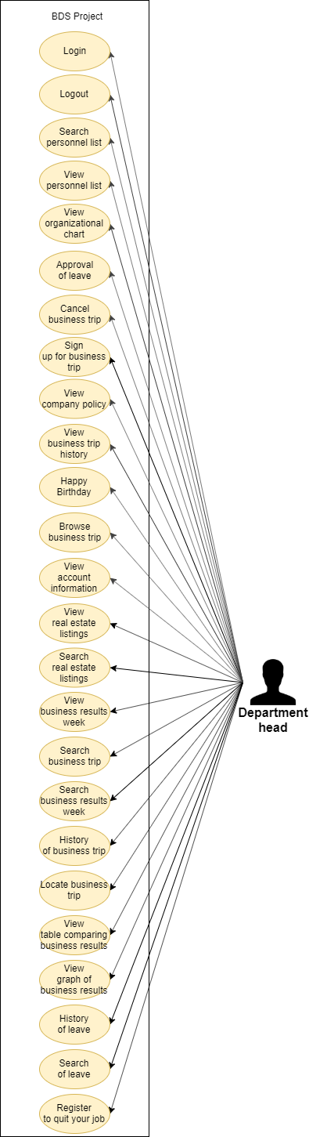

1. **Use Case Diagram Admin**

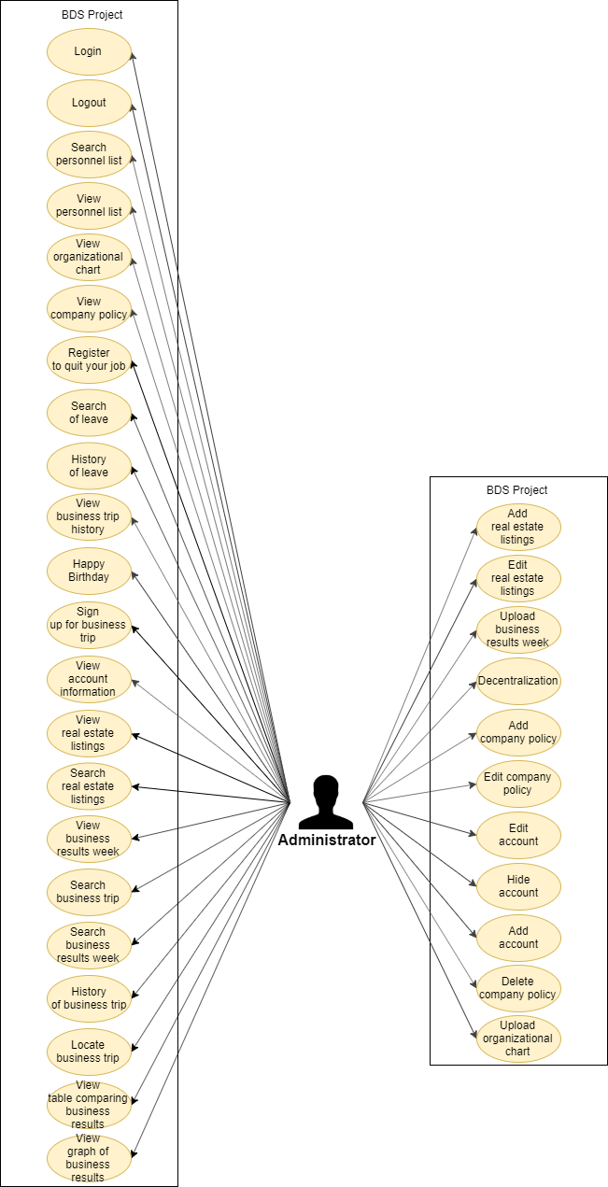

1. **Use Case Diagram Employees**

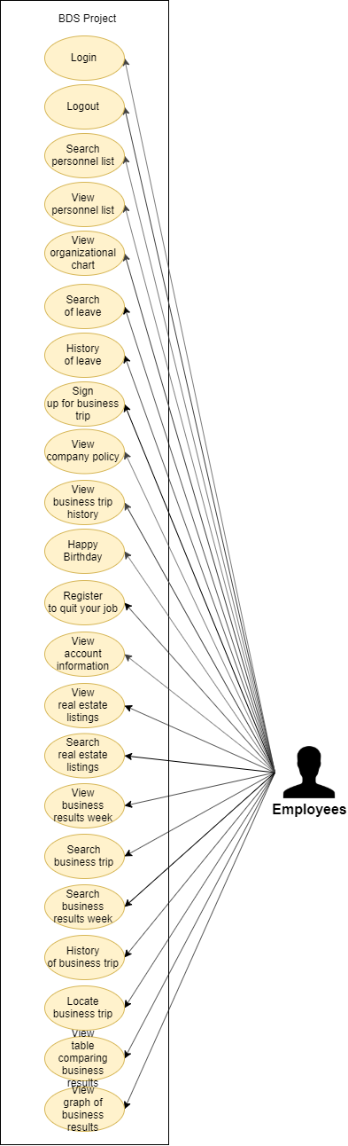

1. **ENTITY TITLE**

|  |  |
| --- | --- |
| **Entity ID** | **Entity Title** |
| E01 | Director |
| E02 | Department Heads |
| E03 | Administrator |
| E04 | Employees |

1. **USE CASE LIST**

List all use cases following this template:

|  |  |  |  |  |
| --- | --- | --- | --- | --- |
| **#** | **UC ID** | **UC Name** | **Description** | **Actors** |
| 01 | FR.01 | Login |  |  |
| 02 | FR.02 | Logout |  |  |
| 03 | FR.03 | Search personnel list |  |  |
| 04 | FR.04 | View personnel list |  |  |
| 05 | FR.05 | Upload organizational chart |  |  |
| 06 | FR.06 | View organizational chart |  |  |
| 07 | FR.07 | Add company policy |  |  |
| 08 | FR.08 | Edit company policy |  |  |
| 09 | FR.09 | Delete company policy |  |  |
| 10 | FR.10 | View company policy |  |  |
| 11 | FR.11 | View account information |  |  |
| 12 | FR.12 | Add account |  |  |
| 13 | FR.13 | Hide account |  |  |
| 14 | FR.14 | Edit account |  |  |
| 15 | FR.15 | Classify |  |  |
| 16 | FR.16 | View real estate listings |  |  |
| 17 | FR.17 | Search real estate listings |  |  |
| 18 | FR.18 | View detail project |  |  |
| 19 | FR.19 | Add real estate listings |  |  |
| 20 | FR.20 | Edit real estate listings |  |  |
| 21 | FR.21 | View business results |  |  |
| 22 | FR.22 | Upload business results |  |  |
| 23 | FR.23 | Filter business results |  |  |
| 24 | FR.24 | View table comparing business results |  |  |
| 25 | FR.25 | View graph of business results |  |  |
| 26 | FR.26 | Sign up for business trip |  |  |
| 27 | FR.27 | Browse business trip |  |  |
| 28 | FR.28 | Cancel business trip |  |  |
| 29 | FR.29 | Locate business trip |  |  |
| 30 | FR.30 | View business trip history |  |  |
| 31 | FR.31 | Search business trip |  |  |
| 32 | FR.32 | Register to quit your job |  |  |
| 33 | FR.33 | History of leave |  |  |
| 34 | FR.34 | Approval of leave |  |  |
| 35 | FR.35 | Search of leave |  |  |
| 36 | FR.36 | Happy Birthday |  |  |

1. **USE CASE DESCRIPTION**

**Account management**

1. **Login/ logout**

|  |  |  |  |
| --- | --- | --- | --- |
| **Use Case ID:** | UC01 | | |
| **Use Case: Name:** | Login or logout | | |
| **Created By:** | Quang Vuong | Update By: |  |
| **Date Created:** | 17/11/2019 | Date Updated: |  |
| **Actors:** | E01, E02, E03, E04 | | |
| **Description:** | E01, E02, E03, E04 login or logout to app BDS | | |
| **Trigger:** | Admin press button “Đăng nhập” or “Đăng xuất” | | |
| **Pre-conditions:** | Login : Account admin does exist  Logout : Users were logined | | |
| **Post-conditions:** | * Success   Login : E01, E02, E03, E04 login success  Logout : E01, E02, E03, E04 logout success   * Failure   Login : E01, E02, E03, E04 can’t login  Logout : E01, E02, E03, E04 can’t logout | | |
| **Normal Flow** | Login:   1. E01, E02, E03, E04 access to mobile app 2. E01, E02, E03, E04 input username 3. E01, E02, E03, E04 input password 4. E01, E02, E03, E04 press button “Đăng nhập”   Logout:   * E01, E02, E03, E04 press button “Đăng xuất” | | |
| **Alternative Flows:** | N/A | | |
| **Exceptions:** | N/A | | |
| **Business Rules** | N/A | | |

1. **Logout/ login**

|  |  |  |  |
| --- | --- | --- | --- |
| **Use Case ID:** | UC02 | | |
| **Use Case: Name:** | Login or logout | | |
| **Created By:** | Quang Vuong | Update By: |  |
| **Date Created:** | 17/11/2019 | Date Updated: |  |
| **Actors:** | E01, E02, E03, E04 | | |
| **Description:** | E01, E02, E03, E04 login or logout to website admin | | |
| **Trigger:** | Admin press button “Đăng nhập” or “Đăng xuất” | | |
| **Pre-conditions:** | Login : Account admin does exist  Logout : Users were logined | | |
| **Post-conditions:** | * Success   Login : E01, E02, E03, E04 login success  Logout : E01, E02, E03, E04 logout success   * Failure   Login : E01, E02, E03, E04 can’t login  Logout : E01, E02, E03, E04 can’t logout | | |
| **Normal Flow** | Login:   1. E01, E02, E03, E04 access to website admin 2. E01, E02, E03, E04 input username 3. E01, E02, E03, E04 input password 4. E01, E02, E03, E04 press button “Đăng nhập”   Logout:   * E01, E02, E03, E04 press button “Đăng xuất” | | |
| **Alternative Flows:** | N/A | | |
| **Exceptions:** | N/A | | |
| **Business Rules** | N/A | | |

**3. Search employees (Search personal list)**

|  |  |  |  |
| --- | --- | --- | --- |
| **Use Case ID:** | UC03 | | |
| **Use Case: Name:** | Search employees | | |
| **Created By:** | Quang Vuong | Update By: |  |
| **Date Created:** | 17/11/2019 | Date Update: |  |
| **Actors:** | E01, E02, E03, E04 | | |
| **Description:** | E01, E02, E03, E04 search employee in mobile app | | |
| **Trigger:** | E01, E02, E03, E04 press button “Tìm kiếm” | | |
| **Pre-conditions:** | E03 was logined | | |
| **Post-conditions:** | * Success   E01, E02, E03, E04 search employee success   * Failure   E01, E02, E03, E04 search empoyee unsuccess | | |
| **Normal Flow:** | 1. E01, E02, E03, E04 access to mobile app 2. E01, E02, E03, E04 press button “Thông tin” 3. E01, E02, E03, E04 press button “Nhân sự” 4. E01, E02, E03, E04 input data 5. E01, E02, E03, E04 press button “Tìm kiếm” | | |
| **Alternative Flows:** | N/A | | |
| **Exceptions:** | N/A | | |
| **Business Rules** | N/A | | |

**4. View employees list (view personal list)**

|  |  |  |  |
| --- | --- | --- | --- |
| **Use Case ID:** | UC04 | | |
| **Use Case: Name:** | View employees list | | |
| **Created By:** | Quang Vuong | Update By: |  |
| **Date Created:** | 17/11/2019 | Date Update: |  |
| **Actors:** | E01, E02, E03, E04 | | |
| **Description:** | E01, E02, E03, E04 view employees list | | |
| **Trigger:** | E01, E02, E03, E04 press button “Nhân sự” | | |
| **Pre-conditions:** | E01, E02, E03, E04 were logined | | |
| **Post-conditions:** | * Success   E01, E02, E03, E04 view employees list success | | |
| **Normal Flow:** | 1. E01, E02, E03, E04 access to mobile app 2. E01, E02, E03, E04 press button “Thông tin” 3. E01, E02, E03, E04 press button “Nhân sự” | | |
| **Alternative Flows:** | N/A | | |
| **Exceptions:** | N/A | | |
| **Business Rules** | N/A | | |

**5. Upload organizational chart**

|  |  |  |  |
| --- | --- | --- | --- |
| **Use Case ID:** | UC05 | | |
| **Use Case: Name:** | Upload organizational chart | | |
| **Created By:** | Quang Vuong | Update By: |  |
| **Date Created:** | 17/11/2019 | Date Update: |  |
| **Actors:** | E03 | | |
| **Description:** | E03 upload organizational chart in website admin | | |
| **Trigger:** | E03 press button “Upload” | | |
| **Pre-conditions:** | E03 was logined | | |
| **Post-conditions:** | * Success   E03 upload organizational chart success | | |
| **Normal Flow:** | 1. E03 access to website admin 2. E03 press button “Thông tin” 3. E03 press button “Sơ đồ tổ chức” 4. E03 choose picture 5. E03 press button “Upload” | | |
| **Alternative Flows:** | N/A | | |
| **Exceptions:** | N/A | | |
| **Business Rules** | N/A | | |

**6. View organizational chart**

|  |  |  |  |
| --- | --- | --- | --- |
| **Use Case ID:** | UC06 | | |
| **Use Case: Name:** | View organizational chart | | |
| **Created By:** | Quang Vuong | Update By: |  |
| **Date Created:** | 17/11/2019 | Date Update: |  |
| **Actors:** | E01, E02, E03, E04 | | |
| **Description:** | E01, E02, E03, E04 view organizational chart in mobile app | | |
| **Trigger:** | E01, E02, E03, E04 press button “Sơ đồ tổ chức” | | |
| **Pre-conditions:** | E01, E02, E03, E04 was logined | | |
| **Post-conditions:** | * Success   E01, E02, E03, E04 view organizational chart success | | |
| **Normal Flow:** | 1. E01, E02, E03, E04 access to mobile app 2. E01, E02, E03, E04 press button “Thông tin” 3. E01, E02, E03, E04 press button “Sơ đồ tổ chức” | | |
| **Alternative Flows:** | N/A | | |
| **Exceptions:** | N/A | | |
| **Business Rules** | N/A | | |

**7. Add company policy**

|  |  |  |  |
| --- | --- | --- | --- |
| **Use Case ID:** | UC07 | | |
| **Use Case: Name:** | Add company policy | | |
| **Created By:** | Anh Minh | Update By: |  |
| **Date Created:** | 12/11/2019 | Date Update: |  |
| **Actors:** | E03 | | |
| **Description:** | E03 want add company policy | | |
| **Trigger:** | E03 click button “Thêm chính sách công ty” | | |
| **Pre-conditions:** | E03 login webapp | | |
| **Post-conditions:** | Add company policy success | | |
| **Normal Flow:** | 1. Access webapp 2. E03 click buttom “Quản lý chính sách công ty” 3. E03 click buttom “Thêm chính sách công ty” 4. E03 enter the information required by the system 5. E03 click buttom “Thêm” 6. Notification display system “Thêm chính sách công ty thành công” | | |
| **Alternative Flows:** | N/A | | |
| **Exceptions:** | N/A | | |
| **Business Rules** | NA | | |

**8. Edit company policy**

|  |  |  |  |
| --- | --- | --- | --- |
| **Use Case ID:** | UC08 | | |
| **Use Case: Name:** | Edit company policy | | |
| **Created By:** | Anh Minh | Update By: |  |
| **Date Created:** | 12/11/2019 | Date Update: |  |
| **Actors:** | E03 | | |
| **Description:** | E03 want edit company policy | | |
| **Trigger:** | E03 click icon edit company policy | | |
| **Pre-conditions:** | E03 login webapp | | |
| **Post-conditions:** | Edit company policy success | | |
| **Normal Flow:** | 1. Access webapp 2. E03 click buttom “Quản lý chính sách công ty” 3. E03 chose company policy cant edit 4. E03 click icon add company policy 5. E03 enter the information required by the system 6. E03 click buttom “Xác nhận” 7. Notification display system “Sửa chính sách công ty thành công” | | |
| **Alternative Flows:** | N/a | | |
| **Exceptions:** | N/a | | |
| **Business Rules** | N/a | | |

**9. Delete company policy**

|  |  |  |  |
| --- | --- | --- | --- |
| **Use Case ID:** | UC09 | | |
| **Use Case: Name:** | Delete company policy | | |
| **Created By:** | Anh Minh | Update By: |  |
| **Date Created:** | 12/11/2019 | Date Update: |  |
| **Actors:** | E03 | | |
| **Description:** | E03 want delete company policy | | |
| **Trigger:** | E03 click icon delete company policy | | |
| **Pre-conditions:** | E03 login webapp | | |
| **Post-conditions:** | Delete company policy success | | |
| **Normal Flow:** | 1. Access webapp 2. E03 click buttom “Quản lý chính sách công ty” 3. E03 chose company policy cant edit 4. E03 click icon delete company policy 5. E03 click buttom “Xác nhận”   Notification display system “Xoá chính sách công ty thành công” | | |
| **Alternative Flows:** | N/a | | |
| **Exceptions:** | N/a | | |
| **Business Rules** | N/a | | |

**10. View company policy**

|  |  |  |  |
| --- | --- | --- | --- |
| **Use Case ID:** | UC10 | | |
| **Use Case: Name:** | View company policy | | |
| **Created By:** | Anh Minh | Update By: |  |
| **Date Created:** | 12/11/2019 | Date Update: |  |
| **Actors:** | E01, E02, E03, E04 | | |
| **Description:** | E01, E02, E03, E04 want view company policy | | |
| **Trigger:** | E01, E02, E03, E04 click company policy | | |
| **Pre-conditions:** | Company policy is initialized | | |
| **Post-conditions:** | E01, E02, E03, E04 view company policy success | | |
| **Normal Flow:** | 1. Access Mobileapp 2. E01, E02, E03, E04 click buttom “Xem thông tin” 3. E01, E02, E03, E04 chose company policy cant view 4. Display system company policy | | |
| **Alternative Flows:** | N/a | | |
| **Exceptions:** | N/a | | |
| **Business Rules** | N/a | | |

**11. View information accounts**

|  |  |  |  |
| --- | --- | --- | --- |
| **Use Case ID:** | UC11 | | |
| **Use Case: Name:** | View information accounts | | |
| **Created By:** | Quang Vuong | Update By: |  |
| **Date Created:** |  | Date Created: | 17/11/2019 |
| **Actors:** | E03 | | |
| **Description:** | E03 view information accounts | | |
| **Trigger:** | E03 press button “Xem thông tin tài khoản” | | |
| **Pre-conditions:** | E03 was logined | | |
| **Post-conditions:** | * Success   E03 view information accounts success | | |
| **Normal Flow:** | 1. E03 access to website admin 2. E03 press button “Xem thông tin tài khoản” | | |
| **Alternative Flows:** | N/A | | |
| **Exceptions:** | N/A | | |
| **Business Rules** | N/A | | |

**12. Add account**

|  |  |  |  |
| --- | --- | --- | --- |
| **Use Case ID:** | UC12 | | |
| **Use Case: Name:** | Add account | | |
| **Created By:** | Anh Minh | Update By: |  |
| **Date Created:** | 12/11/2019 | Date Update: |  |
| **Actors:** | E03 | | |
| **Description:** | E03 want add account | | |
| **Trigger:** | E03 click button “Thêm tài khoản” | | |
| **Pre-conditions:** | E03 login webapp | | |
| **Post-conditions:** | Add account success | | |
| **Normal Flow:** | 1. Access webapp 2. E03 click buttom “Quản lý tài khoản” 3. E03 click buttom “Thêm tài khoản” 4. E03 enter the information required by the system 5. E03 click buttom “Thêm” 6. Notification display system “Thêm tài khoản thành công” | | |
| **Alternative Flows:** | N/A | | |
| **Exceptions:** | N/A | | |
| **Business Rules** | NA | | |

**13. Hide account**

|  |  |  |  |
| --- | --- | --- | --- |
| **Use Case ID:** | UC13 | | |
| **Use Case: Name:** | Hide account | | |
| **Created By:** | Anh Minh | Update By: |  |
| **Date Created:** | 12/11/2019 | Date Update: |  |
| **Actors:** | E03 | | |
| **Description:** | E03 want hide account | | |
| **Trigger:** | E03 click button “Ẩn tài khoản” | | |
| **Pre-conditions:** | E03 login webapp | | |
| **Post-conditions:** | Hide account success | | |
| **Normal Flow:** | 1. Access webapp 2. E03 click buttom “Quản lý tài khoản” 3. E03 chose account cant hide 4. E03 click buttom “Ẩn tài khoản” 5. E03 enter the information required by the system 6. E03 click buttom “Thêm” 7. Notification display system “Thêm tài khoản thành công” | | |
| **Alternative Flows:** | N/A | | |
| **Exceptions:** | N/A | | |
| **Business Rules** | NA | | |

**14. Edit account**

|  |  |  |  |
| --- | --- | --- | --- |
| **Use Case ID:** | UC14 | | |
| **Use Case: Name:** | Edit account | | |
| **Created By:** | Anh Minh | Update By: |  |
| **Date Created:** | 12/11/2019 | Date Update: |  |
| **Actors:** | E03 | | |
| **Description:** | E03 want edit account | | |
| **Trigger:** | E03 click icon edit account | | |
| **Pre-conditions:** | E03 login webapp | | |
| **Post-conditions:** | Edit account success | | |
| **Normal Flow:** | 1. Access webapp 2. E03 click buttom “Quản lý tài khoản” 3. E03 chose account cant edit 4. E03 click icon hide account 5. E03 click buttom “Xác nhận” 6. Notification display system “Ẩn thông tin tài khoản thành công” | | |
| **Alternative Flows:** | N/a | | |
| **Exceptions:** | N/a | | |
| **Business Rules** | N/a | | |

**15. Account classification (classify)**

|  |  |  |  |
| --- | --- | --- | --- |
| **Use Case ID:** | UC15 | | |
| **Use Case Name:** | Account Classification | | |
| **Created By:** | Dat Huynh | Update By: |  |
| **Date Created:** | 13/11/2019 | Date Updated: |  |
| **Actors:** | E03 | | |
| **Description:** | E03 want to classified user accounts | | |
| **Trigger:** | E03 choose feature “Phân quyền tài khoản” | | |
| **Pre-conditions:** | E03 must login to website admin | | |
| **Post-conditions:** | * Success   E03 classificated user accounts at admin web page successfully | | |
| **Normal Flow:** | 1. E03 access to website admin 2. E03 choose feature “Phân quyền tài khoản” 3. E03 choose user account need to classify 4. Classification for that user account | | |
| **Alternative Flows:** | N/A | | |
| **Exceptions:** | N/A | | |
| **Business Rules** | N/A | | |

**16. View project list**

|  |  |  |  |
| --- | --- | --- | --- |
| **Use Case ID:** | UC16 | | |
| **Use Case Name:** | View Project List | | |
| **Created By:** | Dat Huynh | Update By: |  |
| **Date Created:** | 13/11/2019 | Date Updated: |  |
| **Actors:** | E01, E02, E03, E04 | | |
| **Description:** | User want to see all project | | |
| **Trigger:** | E01, E02, E03, E04 choose feature “Dự án Bất động sản” | | |
| **Pre-conditions:** | E01, E02, E03, E04 must login mobile app | | |
| **Post-conditions:** | * Success   E01, E02, E03, E04 view all projects successfully | | |
| **Normal Flow:** | 1. E01, E02, E03, E04 access to moblie app 2. E01, E02, E03, E04 choose feature “Dự án Bất động sản” | | |
| **Alternative Flows:** | N/A | | |
| **Exceptions:** | N/A | | |
| **Business Rules** | N/A | | |

**17. Search the project**

|  |  |  |  |
| --- | --- | --- | --- |
| **Use Case ID:** | UC17 | | |
| **Use Case Name:** | Search the project | | |
| **Created By:** | Dat Huynh | Update By: |  |
| **Date Created:** | 13/11/2019 | Date Updated: |  |
| **Actors:** | E01, E02, E03, E04 | | |
| **Description:** | User want to search the project | | |
| **Trigger:** | E01, E02, E03, E04 choose feature “Dự án Bất động sản” | | |
| **Pre-conditions:** | E01, E02, E03, E04 must login application | | |
| **Post-conditions:** | * Success   E01, E02, E03, E04 view projects need to search successfully   * Failure   E01, E02, E03, E04 view projects need to search un-successfully | | |
| **Normal Flow:** | 1. E01, E02, E03, E04 access to moblie app 2. E01, E02, E03, E04 choose feature “Dự án Bất động sản” 3. E01, E02, E03, E04 choose search button 4. E01, E02, E03, E04 input project need to search | | |
| **Alternative Flows:** | N/A | | |
| **Exceptions:** | N/A | | |
| **Business Rules** | N/A | | |

**18. View project details**

|  |  |  |  |
| --- | --- | --- | --- |
| **Use Case ID:** | UC18 | | |
| **Use Case Name:** | View Project Details | | |
| **Created By:** | Dat Huynh | Update By: |  |
| **Date Created:** | 13/11/2019 | Date Updated: |  |
| **Actors:** | E01, E02, E03, E04 | | |
| **Description:** | User want to see the project details | | |
| **Trigger:** | E01, E02, E03, E04 choose feature “Dự án Bất động sản” | | |
| **Pre-conditions:** | E01, E02, E03, E04 must login mobile app | | |
| **Post-conditions:** | * Success   E01, E02, E03, E04 view project details successfully | | |
| **Normal Flow:** | 1. E01, E02, E03, E04 access to moblie app 2. E01, E02, E03, E04 choose feature “Dự án Bất động sản” 3. E01, E02, E03, E04 choose project | | |
| **Alternative Flows:** | N/A | | |
| **Exceptions:** | N/A | | |
| **Business Rules** | N/A | | |

**19. Add project**

|  |  |  |  |
| --- | --- | --- | --- |
| **Use Case ID:** | UC19 | | |
| **Use Case Name:** | Add Project | | |
| **Created By:** | Dat Huynh | Update By: |  |
| **Date Created:** | 13/11/2019 | Date Updated: |  |
| **Actors:** | E03 | | |
| **Description:** | E03 want to create new project to mobile app | | |
| **Trigger:** | E03 choose feature “Thêm Dự án mới” | | |
| **Pre-conditions:** | E03 must login admin admin website | | |
| **Post-conditions:** | * Success   E03 add new project sucessfully   * Failure   E03 add new project unsuccessfully | | |
| **Normal Flow:** | 1. E03 access to website admin 2. E03 choose feature “Quản lý dự án” 3. E03 choose feature “Thêm Dự án mới” 4. E03 upload all file about new project | | |
| **Alternative Flows:** | N/A | | |
| **Exceptions:** | N/A | | |
| **Business Rules** | N/A | | |

**20. Edit project**

|  |  |  |  |
| --- | --- | --- | --- |
| **Use Case ID:** | UC20 | | |
| **Use Case Name:** | Edit Project | | |
| **Created By:** | Dat Huynh | Update By: |  |
| **Date Created:** | 13/11/2019 | Date Updated: |  |
| **Actors:** | E03 | | |
| **Description:** | E03 want to edit project to mobile app | | |
| **Trigger:** | E03 choose feature “Sửa Dự án mới” | | |
| **Pre-conditions:** | E03 must login admin admin website | | |
| **Post-conditions:** | * Success   E03 edit project sucessfully   * Failure   E03 edit project unsuccessfully | | |
| **Normal Flow:** | 1. E03 access to website admin 2. E03 choose feature “Quản lý dự án” 3. E03 choose feature “Sửa dự án” 4. E03 upload all file about project | | |
| **Alternative Flows:** | N/A | | |
| **Exceptions:** | N/A | | |
| **Business Rules** | N/A | | |

**21. View sales report (View business results)**

|  |  |  |  |
| --- | --- | --- | --- |
| **Use Case ID:** | UC21 | | |
| **Use Case Name:** | View sales report | | |
| **Created By:** | Dat Huynh | Update By: |  |
| **Date Created:** | 13/11/2019 | Date Updated: |  |
| **Actors:** | E01, E02, E03, E04 | | |
| **Description:** | E01, E02, E03, E04 want to view sales report | | |
| **Trigger:** | E01, E02, E03, E04 choose feature “Kết quả kinh doanh tuần” | | |
| **Pre-conditions:** | E01, E02, E03, E04 must login mobile app | | |
| **Post-conditions:** | * Success   E01, E02, E03, E04 view all projects successfully | | |
| **Normal Flow:** | 1. E01, E02, E03, E04 access to moblie app 2. E01, E02, E03, E04 choose feature “Thống kê – Báo cáo” 3. E01, E02, E03, E04 choose feature “Kết quả kinh doanh tuần” | | |
| **Alternative Flows:** | N/A | | |
| **Exceptions:** | N/A | | |
| **Business Rules** | N/A | | |

**22. Import sales report (Upload business results)**

|  |  |  |  |
| --- | --- | --- | --- |
| **Use Case ID:** | UC22 | | |
| **Use Case Name:** | Import sales report | | |
| **Created By:** | Dat Huynh | Update By: |  |
| **Date Created:** | 13/11/2019 | Date Updated: |  |
| **Actors:** | E03 | | |
| **Description:** | E03 want to import sales report | | |
| **Trigger:** | E03 choose feature “Tải lên kết quả kinh doanh” | | |
| **Pre-conditions:** | E03 must login admin admin website | | |
| **Post-conditions:** | * Success   E03 imort sales report sucessfully   * Failure   E03 imort sales report unsuccessfully | | |
| **Normal Flow:** | 1. E03 access to website admin 2. E03 choose feature “Quản lý thống kê báo cáo” 3. E03 choose feature “Tải lên kết quả kinh doanh” 4. E03 import sales report file | | |
| **Alternative Flows:** | N/A | | |
| **Exceptions:** | N/A | | |
| **Business Rules** | N/A | | |

**23. Filter the sales report (Filter business results)**

|  |  |  |  |
| --- | --- | --- | --- |
| **Use Case ID:** | UC23 | | |
| **Use Case Name:** | Filter the sales report | | |
| **Created By:** | Dat Huynh | Update By: |  |
| **Date Created:** | 13/11/2019 | Date Updated: |  |
| **Actors:** | E01, E02, E03, E04 | | |
| **Description:** | E01, E02, E03, E04 want to filter the sales report | | |
| **Trigger:** | E01, E02, E03, E04 choose feature “Thống kê – Báo cáo” | | |
| **Pre-conditions:** | E01, E02, E03, E04 must login application | | |
| **Post-conditions:** | * Success   E01, E02, E03, E04 filter projects successfully   * Failure   E01, E02, E03, E04 filter projects unsuccessfully | | |
| **Normal Flow:** | 1. E01, E02, E03, E04 access to moblie app 2. E01, E02, E03, E04 choose feature “Thống kê – Báo cáo” 3. E01, E02, E03, E04 choose feature “Kết quả kinh doanh tuần” 4. E01, E02, E03, E04 choose filter button 5. E01, E02, E03, E04 input week need to filter | | |
| **Alternative Flows:** | N/A | | |
| **Exceptions:** | N/A | | |
| **Business Rules** | N/A | | |

**24. Compare business results (View table comparing business results)**

|  |  |  |  |
| --- | --- | --- | --- |
| **Use Case ID:** | UC24 | | |
| **Use Case Name:** | Compare business results | | |
| **Created By:** | Dat Huynh | Update By: |  |
| **Date Created:** | 13/11/2019 | Date Updated: |  |
| **Actors:** | E01, E02, E03, E04 | | |
| **Description:** | E01, E02, E03, E04 want to compare business results | | |
| **Trigger:** | E01, E02, E03, E04 choose feature “Thống kê – Báo cáo” | | |
| **Pre-conditions:** | E01, E02, E03, E04 must login application | | |
| **Post-conditions:** | * Success   E01, E02, E03, E04 view compare business results successfully   * Failure   E01, E02, E03, E04 view compare business results unsuccessfully | | |
| **Normal Flow:** | 1. E01, E02, E03, E04 access to moblie app 2. E01, E02, E03, E04 choose feature “Thống kê – Báo cáo” 3. E01, E02, E03, E04 choose feature “So sánh kết quả kinh doanh” | | |
| **Alternative Flows:** | N/A | | |
| **Exceptions:** | N/A | | |
| **Business Rules** | N/A | | |

**25. View graph of business results**

|  |  |  |  |
| --- | --- | --- | --- |
| **Use Case ID:** | UC25 | | |
| **Use Case: Name:** | View graph of business results | | |
| **Created By:** | Nhan Pham | Update By: |  |
| **Date Created:** | 17/11/2019 | Date Updated: |  |
| **Actors:** | E01, E02, E03 & E04 | | |
| **Description:** | E01, E02, E03 & E04 view graph of business results | | |
| **Trigger:** | The E01, E02, E03 & E04 opens the interface ‘Đồ thị kết quả kinh doanh’ | | |
| **Pre-conditions:** | The E01, E02, E03 & E04 has logged in to the system with the E01, E02, E03 & E04 account | | |
| **Post-conditions:** | Success:   * E01, E02, E03 & E04 can view ‘Đồ thị kết quả kinh doanh’ | | |
| **Normal Flow:** | 1. E01, E02, E03 & E04 accept to Mobile app 2. E01, E02, E03 & E04 choose feature ‘thống kê – báo cáo’ on ‘Đồ thị kết quả kinh doanh’ page | | |
| **Alternative Flows:** | N/A | | |
| **Exceptions:** | N/A | | |
| **Business Rules** | N/A | | |

**26. Sign up for business trip**

|  |  |  |  |
| --- | --- | --- | --- |
| **Use Case ID:** | UC26 | | |
| **Use Case: Name:** | Sign up for business trip | | |
| **Created By:** | Nhan Pham | Update By: |  |
| **Date Created:** | 17/11/2019 | Date Updated: |  |
| **Actors:** | E01, E02, E03 & E04 | | |
| **Description:** | E01, E02, E03 & E04 sign up for business trip | | |
| **Trigger:** | The E01, E02, E03 & E04 opens the interface ‘đăng ký chuyến đi công tác’ | | |
| **Pre-conditions:** | The E01, E02, E03 & E04 has logged in to the system with the E01, E02, E03 & E04 account | | |
| **Post-conditions:** | Success:   * E01, E02, E03 & E04 can ‘đăng ký chuyến đi công tác’ | | |
| **Normal Flow:** | 1. E01, E02, E03 & E04 accept to Mobile app 2. E01, E02, E03 & E04 choose feature ‘đăng ký chuyến đi công tác’ 3. E01, E02, E03 & E04 fill out all the information fields 4. E01, E02, E03 & E04 press the send button | | |
| **Alternative Flows:** | N/A | | |
| **Exceptions:** | N/A | | |
| **Business Rules** | N/A | | |

**27. Browse business trip**

|  |  |  |  |
| --- | --- | --- | --- |
| **Use Case ID:** | UC27 | | |
| **Use Case: Name:** | Browse business trip | | |
| **Created By:** | Nhan Pham | Update By: |  |
| **Date Created:** | 18/11/2019 | Date Updated: |  |
| **Actors:** | E01 & E02 | | |
| **Description:** | E01 & E02 browse business trip | | |
| **Trigger:** | The E01 & E02 opens the interface ‘duyệt phiếu chuyến đi công tác’ | | |
| **Pre-conditions:** | The E01 & E02 has logged in to the system with the E01 & E02 account | | |
| **Post-conditions:** | Success:   * E01 & E02 can ‘duyệt phiếu chuyến đi công tác’ | | |
| **Normal Flow:** | 1. E01, E02, E03 & E04 accept to Mobile app 2. E01 & E02 choose feature ‘duyệt phiếu chuyến đi công tác’ 3. E01 & E02 press the button ‘duyệt’ | | |
| **Alternative Flows:** | N/A | | |
| **Exceptions:** | N/A | | |
| **Business Rules** | N/A | | |

**28. Cancel business trip**

|  |  |  |  |
| --- | --- | --- | --- |
| **Use Case ID:** | UC28 | | |
| **Use Case: Name:** | Cancel business trip | | |
| **Created By:** | Nhan Pham | Update By: |  |
| **Date Created:** | 18/11/2019 | Date Updated: |  |
| **Actors:** | E01 & E02 | | |
| **Description:** | E01 & E02 cancel business trip | | |
| **Trigger:** | The E01 & E02 opens the interface ‘hủy chuyến đi công tác’ | | |
| **Pre-conditions:** | The E01 & E02 has logged in to the system with the E01 & E02 account | | |
| **Post-conditions:** | Success:   * E01 & E02 can ‘hủy chuyến đi công tác’ | | |
| **Normal Flow:** | 1. E01, E02, E03 & E04 accept to Mobile app 2. E01 & E02 choose feature ‘hủy chuyến đi công tác’ 3. E01 & E02 enter the information fields to search | | |
| **Alternative Flows:** | N/A | | |
| **Exceptions:** | N/A | | |
| **Business Rules** | N/A | | |

**29. Locate business trip**

|  |  |  |  |
| --- | --- | --- | --- |
| **Use Case ID:** | UC29 | | |
| **Use Case: Name:** | Locate business trip | | |
| **Created By:** | Nhan Pham | Update By: |  |
| **Date Created:** | 18/11/2019 | Date Updated: |  |
| **Actors:** | E01, E02, E03 & E04 | | |
| **Description:** | E01, E02, E03 & E04 locate business trip | | |
| **Trigger:** | The E01, E02, E03 & E04 opens the interface ‘định vị chuyến công tác’ | | |
| **Pre-conditions:** | The E01, E02, E03 & E04 has logged in to the system with the E01, E02, E03 & E04 account | | |
| **Post-conditions:** | Success:   * E01, E02, E03 & E04 accept to Mobile app * E01, E02, E03 & E04 can ‘định vị chuyến công tác’ | | |
| **Normal Flow:** | 1. E01, E02, E03 & E04 choose feature ‘định vị chuyến công tác’ on đăng ký chuyến công tác’ page | | |
| **Alternative Flows:** | N/A | | |
| **Exceptions:** | N/A | | |
| **Business Rules** | N/A | | |

**30. View business trip history**

|  |  |  |  |
| --- | --- | --- | --- |
| **Use Case ID:** | UC30 | | |
| **Use Case: Name:** | View business trip history | | |
| **Created By:** | Nhan Pham | Update By: |  |
| **Date Created:** | 17/11/2019 | Date Updated: |  |
| **Actors:** | E01, E02, E03 & E04 | | |
| **Description:** | E01, E02, E03 & E04 view business trip history | | |
| **Trigger:** | The E01, E02, E03 & E04 opens the interface ‘lịch sử chuyến công tác’ | | |
| **Pre-conditions:** | The E01, E02, E03 & E04 has logged in to the system with the E01, E02, E03 & E04 account | | |
| **Post-conditions:** | Success:   * E01, E02, E03 & E04 can view ‘lịch sử chuyến công tác’ | | |
| **Normal Flow:** | 1. E01, E02, E03 & E04 accept to Mobile app 2. E01, E02, E03 & E04 choose feature ‘chuyến công tác’ on ‘lịch sử chuyến công tác’ page | | |
| **Alternative Flows:** | N/A | | |
| **Exceptions:** | N/A | | |
| **Business Rules** | N/A | | |

**31. Search business trip**

|  |  |  |  |
| --- | --- | --- | --- |
| **Use Case ID:** | UC31 | | |
| **Use Case: Name:** | Search business trip | | |
| **Created By:** | Nhan Pham | Update By: |  |
| **Date Created:** | 17/11/2019 | Date Updated: |  |
| **Actors:** | E01, E02, E03 & E04 | | |
| **Description:** | E01, E02, E03 & E04 search business trip | | |
| **Trigger:** | The E01, E02, E03 & E04 opens the interface ‘tìm kiếm chuyến đi công tác’ | | |
| **Pre-conditions:** | The E01, E02, E03 & E04 has logged in to the system with the E01, E02, E03 & E04 account | | |
| **Post-conditions:** | Success:   * E01, E02, E03 & E04 can ‘tìm kiếm chuyến đi công tác’   Failure:   * E01, E02, E03 & E04 can’t ‘tìm kiếm chuyến đi công tác’ | | |
| **Normal Flow:** | 1. E01, E02, E03 & E04 accept to Mobile app 2. E01, E02, E03 & E04 choose feature ‘tìm kiếm chuyến đi công tác’ 3. E01, E02, E03 & E04 enter the information fields to search | | |
| **Alternative Flows:** | N/A | | |
| **Exceptions:** | N/A | | |
| **Business Rules** | N/A | | |

**32. Register to quit your job**

|  |  |  |  |
| --- | --- | --- | --- |
| **Use Case ID:** | UC32 | | |
| **Use Case: Name:** | Register to quit your job | | |
| **Created By:** | Nhan Pham | Update By: |  |
| **Date Created:** | 17/11/2019 | Date Updated: |  |
| **Actors:** | E01, E02, E03 & E04 | | |
| **Description:** | E01, E02, E03 & E04 register to quit your job | | |
| **Trigger:** | The E01, E02, E03 & E04 opens the interface ‘đăng ký nghỉ việc’ | | |
| **Pre-conditions:** | The E01, E02, E03 & E04 has logged in to the system with the E01, E02, E03 & E04 account | | |
| **Post-conditions:** | Success:   * E01, E02, E03 & E04 can ‘đăng ký nghỉ việc’ | | |
| **Normal Flow:** | 1. E01, E02, E03 & E04 accept to Mobile app 2. E01, E02, E03 & E04 choose feature ‘đăng ký nghỉ việc’ 3. E01, E02, E03 & E04 fill out all the information fields 4. E01, E02, E03 & E04 press the send button | | |
| **Alternative Flows:** | N/A | | |
| **Exceptions:** | N/A | | |
| **Business Rules** | N/A | | |

**33. View history of leave**

|  |  |  |  |
| --- | --- | --- | --- |
| **Use Case ID:** | UC33 | | |
| **Use Case: Name:** | View history of leave | | |
| **Created By:** | Nhan Pham | Update By: |  |
| **Date Created:** | 17/11/2019 | Date Updated: |  |
| **Actors:** | E01, E02, E03 & E04 | | |
| **Description:** | E01, E02, E03 & E04 view history of leave | | |
| **Trigger:** | The E01, E02, E03 & E04 opens the interface ‘lịch sử nghỉ việc’ | | |
| **Pre-conditions:** | The E01, E02, E03 & E04 has logged in to the system with the E01, E02, E03 & E04 account | | |
| **Post-conditions:** | Success:   * E01, E02, E03 & E04 can view ‘lịch sử nghỉ việc’ | | |
| **Normal Flow:** | 1. E01, E02, E03 & E04 accept to Mobile app 2. E01, E02, E03 & E04 choose feature ‘nghỉ việc’ on ‘lịch sử nghỉ việc’ page | | |
| **Alternative Flows:** | N/A | | |
| **Exceptions:** | N/A | | |
| **Business Rules** | N/A | | |

**34. Approval of leave**

|  |  |  |  |
| --- | --- | --- | --- |
| **Use Case ID:** | UC34 | | |
| **Use Case: Name:** | Approval of leave | | |
| **Created By:** | Nhan Pham | Update By: |  |
| **Date Created:** | 18/11/2019 | Date Updated: |  |
| **Actors:** | E01 & E02 | | |
| **Description:** | E01 & E02 approval of leave | | |
| **Trigger:** | The E01 & E02 opens the interface ‘duyệt đơn nghỉ việc’ | | |
| **Pre-conditions:** | The E01 & E02 has logged in to the system with the E01 & E02 account | | |
| **Post-conditions:** | Success:   * E01 & E02 can ‘duyệt đơn nghỉ việc’ | | |
| **Normal Flow:** | 1. E01, E02, E03 & E04 accept to Mobile app 2. E01 & E02 choose feature ‘duyệt đơn nghỉ việc’ 3. E01 & E02 press the button ‘duyệt’ | | |
| **Alternative Flows:** | N/A | | |
| **Exceptions:** | N/A | | |
| **Business Rules** | N/A | | |

**35. Search of leave**

|  |  |  |  |
| --- | --- | --- | --- |
| **Use Case ID:** | UC35 | | |
| **Use Case: Name:** | Search of leave | | |
| **Created By:** | Nhan Pham | Created By: |  |
| **Date Created:** | 17/11/2019 | Date Created: | 12/11/2019 |
| **Actors:** | E01, E02, E03 & E04 | | |
| **Description:** | E01, E02, E03 & E04 search of leave | | |
| **Trigger:** | The E01, E02, E03 & E04 opens the interface ‘tìm kiếm đơn xin nghỉ việc’ | | |
| **Pre-conditions:** | The E01, E02, E03 & E04 has logged in to the system with the E01, E02, E03 & E04 account | | |
| **Post-conditions:** | Success:   * E01, E02, E03 & E04 can ‘tìm kiếm đơn xin nghỉ việc’   Failure:   * E01, E02, E03 & E04 can’t ‘tìm kiếm đơn xin nghỉ việc’ | | |
| **Normal Flow:** | 1. E01, E02, E03 & E04 accept to Mobile app 2. E01, E02, E03 & E04 choose feature ‘tìm kiếm đơn xin nghỉ việc’ 3. E01, E02, E03 & E04 enter the information fields to search | | |
| **Alternative Flows:** | N/A | | |
| **Exceptions:** | N/A | | |
| **Business Rules** | N/A | | |

**36. Happy Birthday**

|  |  |  |  |
| --- | --- | --- | --- |
| **Use Case ID:** | UC36 | | |
| **Use Case: Name:** | Happy birthday | | |
| **Created By:** | Nhan Pham | Update By: |  |
| **Date Created:** | 18/11/2019 | Date Updated: |  |
| **Actors:** | E01, E02, E03 & E04 | | |
| **Description:** | E01, E02, E03 & E04 received notification | | |
| **Trigger:** | The E01, E02, E03 & E04 opens the interface ‘trang chủ’ | | |
| **Pre-conditions:** | The E01, E02, E03 & E04 has logged in to the system with the E01, E02, E03 & E04 account | | |
| **Post-conditions:** | Success:   * E01, E02, E03 & E04 can receive ‘chúc mừng sinh nhật | | |
| **Normal Flow:** | 1. E01, E02, E03 & E04 accept to Mobile app 2. E01, E02, E03 & E04 received notification ‘chúc mừng sinh nhật’ on ‘trang chủ’ page | | |
| **Alternative Flows:** | N/A | | |
| **Exceptions:** | N/A | | |
| **Business Rules** | N/A | | |